BEGINNER / FOUNDATION (LEVEL 0–1)
- Introduction to Test Management
- Why Test Management Tools are needed
- TestRail Overview
- TestRail Editions (Cloud vs Server)
- TestRail User Interface & Navigation
- TestRail Terminology
- Projects in TestRail
- Project Types
- Single Repository
- Multiple Test Suites

1. Introduction to Test Management
Test Management is the process of planning, organizing, monitoring, and controlling testing activities throughout the software development lifecycle. It ensures testing is systematic, traceable, and aligned with project goals. Effective test management helps teams deliver high-quality software by tracking test coverage, execution progress, and defects.

Without Test Management :
- Test cases in Excel
- Execution tracked in emails / chats
- No clear coverage
- No audit trail
With Test Management :
- Central place for: Test cases, Test execution, Reports
- Traceability to requirements
- Reusability

Why Test Management Tools are Needed
Problems with Excel /Manual Tracking :
Problem | Impact
Multiple Excel versions | Data inconsistency
No live status | Managers blind
No history | Audit issues
Hard to scale | Chaos in regression

What Test Management Tools Solve :
- Central repository
- Standard workflows
- Real-time dashboards
- Traceability
- Scalability

3. TestRail Overview
TestRail is a web-based test management tool used to manage test cases, test runs, and test plans. It integrates with defect tracking tools like Jira and supports manual and automated testing workflows with detailed reporting.
Component | Purpose
Projects | Logical container
Test Suites | Organize test cases
Test Cases | Actual test scenarios
Test Runs | Execution container
Reports | Metrics & status

4. TestRail Editions (Cloud vs Server)

TestRail Cloud :

Hosted by TestRail

No installation

Faster setup

Subscription-based

TestRail Server :

Installed on company servers

Full data control

Requires infra & maintenance
- Complex setup

Feature | Cloud | Server
Setup | Easy | Complex
Maintenance | TestRail | Company
Data Control | Limited | Full
Cost | Subscription | One-time + infra

5. TestRail User Interface & Navigation
The TestRail UI is organized into Projects, Test Cases, Test Runs & Results, Reports, and Administration. Navigation is intuitive with breadcrumb trails, filters, and quick-access menus for efficient test management.

6. TestRail Terminology
Term | Meaning
Test Case | Single test scenario
Test Suite | Collection of test cases
Test Run | Execution instance
Test Plan | Group of test runs
Milestone | Release/version
Status | Pass/Fail/Blocked

7. Projects in TestRail
A project represents a product or application under test. Each project contains test cases, test runs, milestones, and reports. Projects help organize testing work by application or release.

8. Project Types
TestRail supports Single Repository and Multiple Test Suites project types. The selection impacts how test cases are organized and reused across releases.

9. Single Repository

What it Means :
- One flat list of test cases
- No separate suites
- Simple structure

When to Use :
- Small projects
- POCs
- Very early stage products

Project
└── Test Cases (single list)
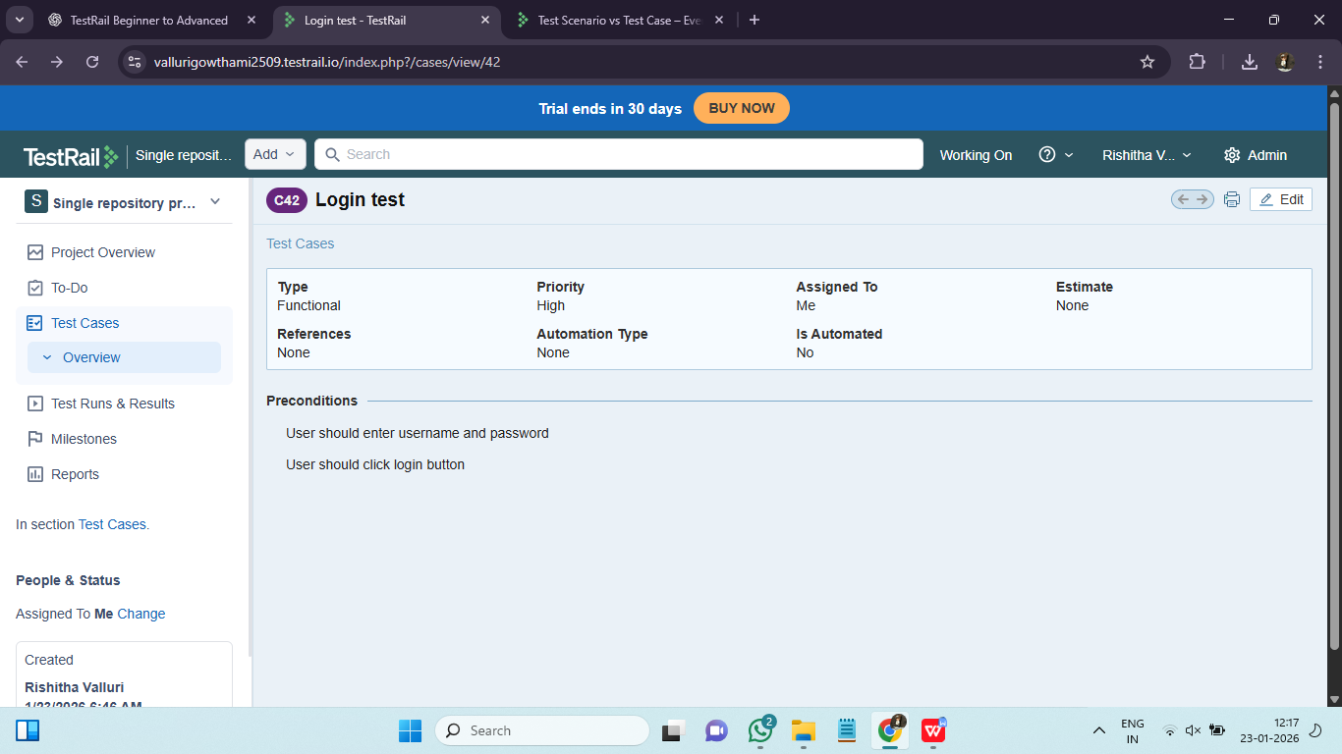

10. Multiple Test Suites

What it Means :

Test cases organized into Suites

Logical grouping (modules/features)

When to Use :

Medium to large projects

Regression testing

Multi-module apps

Project
├── Login Suite
├── Payments Suite
├── Reports Suite
└── Admin Suite

